**Brooklyn torah gazette**

**For parshas shelach 5780**

Volume 4, Issue 37 (Whole Number 189) 28 Shavuos 5780/ June 20, 2020

**Printed L’illuy nishmas Nechama bas R’ Noach, a”h**

**Burial Society for NY’s Jewish Poor Faces**

**A Backlog of Bodies**

**By Stewart Ain**

***Hebrew Free Burial Association, overwhelmed by***

***Covid-19, braces for a second wave.***

[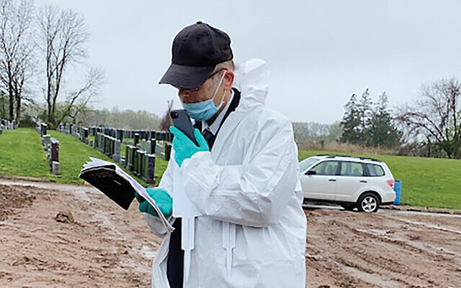](https://static.timesofisrael.com/jewishwdev/uploads/2020/06/20.jpg)

“It’s been crazy,” said Rabbi Shmuel Plafker, the chaplain of Staten Island’s Mount Richmond Cemeter for more than 45 years. He observed that the most

difficult part has been “keeping up with the schedule.” Photos courtesy of Hebrew Free Burial Association

Like all relatives and friends who come to Mount Richmond Cemetery in Staten Island during the coronavirus pandemic for the burial of a loved one or friend, Michael Tokar was asked to wait. He sat in his car until his father’s body could be brought to the site by four workers and then placed in a grave and covered with dirt by a machine.

But after a few minutes, Rabbi Shmuel Plafker walked up to Tokar’s car and told him the burial of his father, David, 92, would not happen that day.

“The hospital was so overwhelmed and when the funeral director came to pick up the body, it couldn’t be located,” explained Rabbi Plafker, who officiates at all burials at Mount Richmond Cemetery. Tokar “was asked to come back the next day. He understood.”



**A Hebrew Free Burial refrigerator trailer the group plans to keep in the event of a surge of Covid deaths. Photo courtesy of Hebrew Free Burial Association**

The coronavirus pandemic has impacted all aspects of the Jewish mourning ritual: There are few in-person funerals; eulogies are recited at graveside and attendees are limited in number; some cemeteries require attendees to remain in their cars; and shiva gatherings are done on Zoom.

And as the Covid-19 crisis has dragged on through the spring, the Hebrew Free Burial Association has also become overwhelmed with bodies of indigent Jews who need burial.

Mount Richmond Cemetery is owned by the association, which was founded in 1888. It handles all burials of Jews who die without funds for funeral expenses. Since 2010, it has averaged about 360 burials annually. But so far this year the number is nearly 300 “and the year is not even half finished,” according to Amy Koplow, the organization’s executive director.

“We did 10 burials in one day,” she recalled. “That was a record breaker. But the next week, we did 11 burials in one day. … The majority of our cases are from the five boroughs, with most coming from Brooklyn and Queens. Now, there have been many cases from Nassau and Suffolk and Westchester, as well as from New Jersey and Rockland. We serve everybody who is Jewish.”

“It’s been crazy,” said Rabbi Plafker, the cemetery’s chaplain for more than 30 years. He observed that the most difficult part has been “keeping up with the schedule.”

Normally when bodies arrive, they are taken to a building where they are prepared by the chevra kadisha, volunteers who prepare the body for burial in accordance with Jewish law. But because of the increasing number of coronavirus victims, Koplow said they ran out of room and bought a free-standing refrigerator to store an additional four bodies.

“We quickly saw there was no way that would be sufficient either, because the week of March 29 we did 25 burials,” Koplow said as she looked through her diary. “In two weeks, we had gone from 10 to 25 burials and of those, 14 were Covid-19. So on April 3, we had to buy a 40-foot refrigerator trailer and had a carpenter go in and build shelving to store 100 bodies.

“The trailer cost us $12,200 and it cost us money to have it delivered on a flatbed truck. Then we hooked it up to a diesel generator that we rented at a cost of $100. I eventually paid a contractor to hook it up to electricity because it was getting too expensive.”

**Running out of prayer shawls**

Hebrew Free Burial raised about $1 million last year in donations. Koplow said it will need to raise $2 million by the end of this year because of all the added expenses. She noted that UJA-Federation of New York recognized the need earlier this year and already awarded a grant of $250,000.

Because of the surge in burials, Hebrew Free Burial was on the verge of running out of the prayer shawls in which bodies are interred. In early March it had about 60 taleisim, but they were gone by the second week of April. A call went out for more and within 48 hours 150 had been collected. It now has at least 2,000 that have been donated from as far away as Oregon and Florida.

Although the number of deaths per day from Covid-19 has been declining since early May, Hebrew Free Burial plans to keep the refrigerator trailer in the event of a surge. New York City’s Office of the Chief Medical Examiner may also release bodies now being stored in its refrigerated trailers.

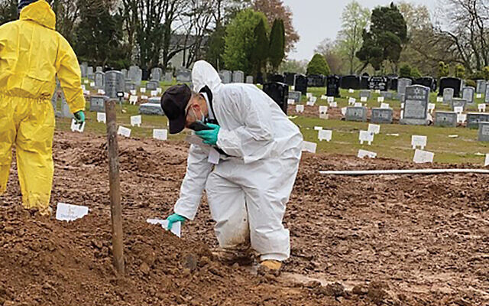

A spokesperson for the medical examiner said the city has as many as 1,500 bodies in “permanent storage” awaiting their family’s plans regarding cremation or burial. She did not know how many might be Jewish.

Koplow said “we expect at some point when the medical examiner’s office does its research that there will be many, many cases of Jewish people whose bodies were not claimed. We get cases like that in non-Covid-19 times.”

The medical examiner’s office does an initial investigation to identify families of unclaimed bodies. If none are found, the case is turned over to the public administrator, whose office administers estates and protects the deceased’s property from waste, loss or theft; makes burial arrangements when there are no close relatives, and conducts an investigation to discover all assets.

If no relatives can be found, a public administrator looks for evidence of the person’s religion, such as a mezuzah or a Chanukah menorah in the home. If the person is Jewish, the Hebrew Free Burial Association handles the burial.

But, said Lois Rosenblatt, the public administrator for Queens, “because we are under a lockdown, our staff is not going into people’s apartments at this time.”

As a result, unclaimed bodies are buried in New York’s City’s potter’s field on Hart Island, one of the largest public cemeteries in the United States.

If a relative is later found, or the deceased’s religion is eventually determined, “people will be disinterred and buried where they properly belonged,” said Rosenblatt.

Koplow said if Hebrew Free Burial Association learns of a Jew who was buried in potter’s field, it will ask to disinter and then rebury the body “with a Jewish burial in our cemetery.”

“We are dealing with a Queens disinterment right now,” she said, noting that her organization pays all the costs.

A day after being asked to wait, Michael Tokar, who lives just two miles from Mount Richmond Cemetery, returned for his father’s burial. He sat in his car near the grave and listened on his cell phone while Rabbi Plafker officiated at the burial service while wearing a protective suit, mask and gloves.

Tokar said later that his father, who emigrated from the former Soviet Union 25 years ago, had gone to the hospital after experiencing kidney pain, was diagnosed with Covid-19 and died two days later. Tokar said he first learned that his father had been ill only when the hospital called to say he died.

*Reprinted from the June 2, 2020 website of the Jewish Week (New York)*

**Thoughts that Count**

*Every one a ruler ("nasi") among them (Numbers 13:2)*

The Hebrew word "nasi" is composed of the words "ein" ("nothing") and "yeish" ("something"). A Jewish leader who is humble and considers himself "nothing" is the only kind of leader who is truly "something." Likewise, a leader who thinks he is "something" is not a true leader at all. *(Degel Machane Efraim)*

*And we were in our own sight as grasshoppers, and so we were in their sight (Numbers 13:33)*

Relating how they were perceived by others was actually one of the sins of the spies. Reporting that they felt "as grasshoppers" is one thing, but saying that the feeling was mutual was another. For one should not care about this at all...*(Rabbi Menachem Mendel of Kotzk)*

*Reprinted from the Parshat Shelach 5755 issue of L’Chaim Weekly.*

**Rabbi Berel Wein on**

**Parshat Shelach**

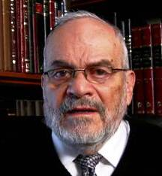

The Land of Israel has always been a challenge to the People of Israel. There are many reasons for this, both obvious and subtle. The Land of Israel plays a central role in Judaism, in Jewish life, within its laws and world view. Yet, for a great part of Jewish history, the Jewish People itself was absent from the Land of Israel.

Because of this absence, the Land of Israel was not a reality in Jewish everyday life. It became a goal, a spiritual value, an imaginary place of perfection and holiness. It adopted a utopian character, a place well neigh impossible to translate into reality.

Though, over the past century the Land of Israel and the People of Israel again began to be joined one to another in actuality, it became difficult for many Jews to accept the reality of the Land and the People as opposed to the imaginary dream that had existed for millennia.

This I think helps explain the attitude of certain sections of Jewish society, interestingly enough both very secular and very religiously observant, that somehow finds it difficult to adjust to the miraculous and unforeseen reunification of the Land and the People that has occurred in our time. Expecting perfection or purely holy behavior, the existing reality is therefore frustrating and even disappointing to them and they reject this miracle of Jewish rebirth and of the great process of the rebuilding of the Jewish People in the Land of Israel in our time.

When the spies that Moshe sent rejected the Land of Israel thousands of years ago, they also did it out of ill perceived but relatively high motives. They saw the dangers inherent in the creation of any national entity and of the potential divisions that would necessarily arise within Jewish society. They realized that they would have to fight wars against strong enemies and work to till the land and develop an economy and a way of life. They realized that all of this somehow had to be compatible with the intrinsic holiness of the Land and of its special qualities.

They were nervous that “the eyes of the Lord their God would be fixed upon them and the Land from the beginning of the year till its conclusion.” They would have to combine the sword, the plow and holy learning in their personal and national lives. This was and is an enormous challenge that the generation of the desert shrank from. It is much easier to retain and be loyal to an image of the imaginary Land of Israel than to the nitty gritty of the actual Land of Israel.

Calev and Yehoshua said “aloh na’aleh” we will be worthy to elevate ourselves to meet that challenge. Our generation is in the midst of the third attempt of the Jewish People to realize its physical and spiritual ambitions in the Land of Israel. It is a difficult process but one that we cannot or should not shirk from attempting to succeed and thereby justify all that has happened to us in our past history.

*Reprinted from this week’s website of Rabbiwein.com*

**More Thoughts on**

**Parshat Shelach**

Only rebel not against G-d (Numbers 14:9)

Nothing in the spies' report encouraged open rebellion against G-d. On the surface, they were merely reporting facts.

Nonetheless, Calev and Joshua responded by cautioning them not to rebel. For the fear and trembling they expressed in the face of the land's giant inhabitants and walled cities was what constituted their rebellion.

As King David stated in Psalms, "G-d is with me; I will not fear what man may do to me." Believing in G-d causes a person to cease fearing man. *(Rabbeinu Bechaye)*

*Reprinted from the Parshat Shelach 5755 issue of L’Chaim Weekly.*

**Parshas Shelach**

**Stronger than G-d**

By Rabbi Bentzion Shafier

Founder of TheSmuz.com

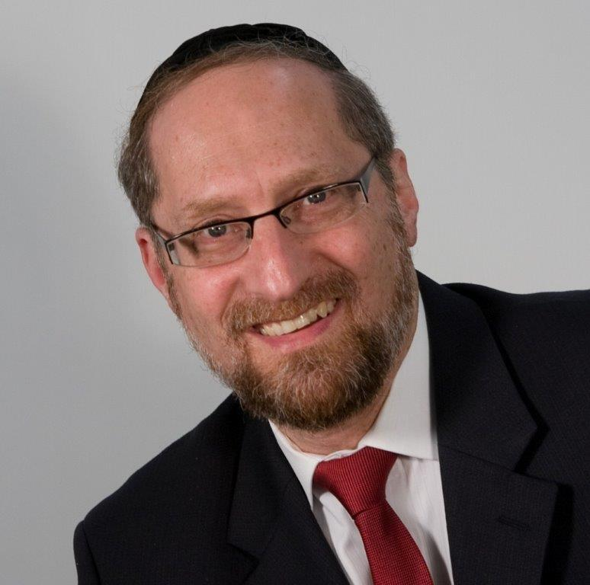

*But the men who had ascended with him said, “We cannot ascend to that people for it is stronger than us!”*

— Bemidbar 13:31

The miraglim (spies) came back with the report that Eretz Yisrael was occupied by giants that couldn’t be vanquished. The expression that they used, though, was “stronger than him.” Rashi explains that the “him” they were referring to was HASHEM. The spies were saying that the giants were so powerful that even HASHEM couldn’t win against them.

This Rashi is very difficult to understand. HASHEM created the heavens and the earth and all that they contain. The people of that generation saw this more clearly than any other. They had all lived through the ten plagues. A few months earlier, they had witnessed HASHEM split the sea into twelve parts. How is it possible that they could believe something so foolish — that these mere mortals, large as they might be, were actually stronger than HASHEM?

This might be easier to answer with a different perspective.

**The vastness of space**

In Selichos we say, “Amongst all of the gentile nations, there is no king as powerful as You, HASHEM.” But comparing HASHEM to mere mortal seems insulting. How can Chazal use such a poor comparison, one that so belittles (if it could be) the honor of HASHEM?

The answer to this lies in the difference between knowing something and feeling it. As an example, let’s look at the phenomenon called distance. If you are sitting in a large room, the distance from you to the wall isn’t great, perhaps one hundred or two hundred feet. The distance between New York City and Tel Aviv, however, is of a different magnitude. Even flying at five hundred miles an hour, it takes twelve hours to arrive — because six thousand miles is a great expanse.

Yet in terms of measuring distance, continents aren’t considered remote. The distance between the earth and the moon is approximately 250,000 miles. And the distance between the earth and sun is approximately ninety-two million miles, a gap so large that it is difficult to relate to. To get a sense of how far that is, let’s look at an interesting fact.

The sun is the main source of light, heat, and energy on earth. Scientists estimate that the core temperature of the sun is sixteen million degrees. If you were to take a single grain of sand, heat it to that level, and bring it back to earth, it would cause everything within a sixty-mile radius to erupt into flame. Even a speck of matter that hot contains so much energy that it would consume everything around it.

Yet the sun is so far off in space that the rays of light emanating from it spread out, and only a fraction of them enter into our atmosphere and are converted into energy. And so, the temperature on earth can sustain life.

What would happen if the distance were less? Say forty-five million miles? The heat on the planet would rise radically, and life would cease to exist. However, because we are so distant from the sun, the energy dissipates. Only two billionth of one percent of it reaches us, so it gets to be a nice balmy seventy-five degrees in the spring.

**A yardstick for measuring space**

When it comes to the known universe, though, distances like these aren’t even noticeable. In fact, objects in space are so far apart that measuring them with miles is like measuring the distance between New York City and Los Angeles in inches. A different frame of reference is needed, and so the speed of light is used.

Light travels at approximately 186,000 miles per second. If you mark the time that it takes for light to travel from an object in the sky to earth, you can calculate its distance. Convert the time span into seconds and multiply that by 186,000 miles, and you’ll know how many miles away the object is from earth. Using this system, the distance from the earth to the moon is a mere one and a quarter light seconds. From the earth to the sun is just eight minutes. And now we can put the universe into perspective.

The star closest to the sun is Alpha Centauri. Light traveling from it takes fifteen hundred days to arrive here. It is so far away that light hurtling at 186,000 miles a second takes more than four years to bridge the expanse.

But Alpha Centauri and our sun are not the only stars in the universe. The night sky sports a vast array of stars, stretching out as far as the eye can see. Astronomers estimate that in the Milky Way galaxy alone, there are over a hundred billion stars. Each one is as powerful as our own sun. And most of them are as distant from their neighbors as the sun is from Alpha Centauri. The entire Milky Way unfolds across a span of empty space that baffles the mind.

But of course, the Milky Way is not the only galaxy in the cosmos. There are others. Many others. And here is where things start to get interesting. To help us understand the size of the cosmos, scientists use a parable. If you were to compare the Milky Way galaxy to the rest of the known universe, it would be similar to comparing a coffee cup to the United States of America! There are over a hundred billion galaxies, each containing over a hundred billion stars, spreading across thirteen billion light years of space that is ever expanding.

The Chovos HaLevavos asks: why did HASHEM need to create so vast and complex a universe? He answers that part of the reason is that we should have a glimpse into the greatness of our Creator. If this is the Creation, what does that tell me about the Creator?

So if we know this, how is it possible that we aren’t filled with a powerful sense of awe and reverence for our Creator? Why don’t we tremble when we stand in front of HASHEM? But therein lies the problem. When we deal with things so beyond ourselves, we tend to lose perspective, and they stop having an impact on us. We know it — but we don’t feel it.

This seems to be the answer to the expression in Selichos. Of course, it’s a huge understatement to compare HASHEM to a mortal king. But a powerful king evokes real fear in people’s hearts. The fact that HASHEM fills the cosmos is too removed; the fact that He is stronger than even the mightiest tyrant is far more tangible.

And this seems to be the answer to how the spies could think the giants were more powerful that HASHEM. Yes, HASHEM is strong and He can split the sea, but that is far removed from daily life. These were giants taller than trees. Even though on an intellectual level, the spies recognized that HASHEM was far more powerful, on an emotional level, it didn’t register, so they feared the giants even more than HASHEM.

**Even HASHEM can’t get me out of this**

This concept has great relevance to us when we find ourselves in situations that seem insurmountable. Much of the problem is that we view things from our small world, and so we find ourselves thinking things like, “I owe so much money that even HASHEM can’t bail me out of this.” While intellectually, we recognize the foolishness of these thoughts, on an emotional level, they still overwhelm us.

As big as our problems are, to HASHEM they are tiny. By focusing on the fact that HASHEM created the heavens and the earth and all that they contain, we can feel on an emotional level that He is all-powerful and can easily redeem us from even our worst fears.

*Reprinted from this week’s website on TheShmuz.com This is an excerpt from the [Shmuz on the Parsha book](https://theshmuz.com/product/shmuz-on-the-parsha-book/).*

**The Wood Gatherer**

From the Talks of the Lubavitcher Rebbe

Rabbi Menachem Mendel Schneerson, Zt”l

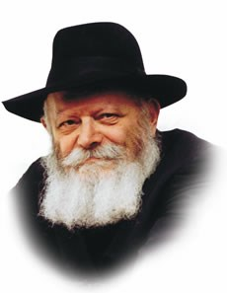

This week's Torah reading, Shelach, contains several seemingly disparate elements: an account of the 12 spies; the laws pertaining to idolatry; the story of the Jew who gathered wood on Shabbat.

Rashi, in his commentary, explains the connection between idolatry and the desecration of Shabbat: "[This comes to teach that] desecrating Shabbat is akin to worshipping idols, for both are the antithesis of all the mitzvot."

This, however, is insufficient to explain the juxtaposition of both these concepts with the central theme of this week's Torah portion -- the story of the spies who went to investigate the land before the Jewish people's entry into Israel.

Idolatry is one of the gravest sins. In fact, "one must give up one's life rather than transgress." Throughout the ages Jews have forfeited their lives rather than deny their belief.

Interestingly, this occurred even when all that was demanded of them was a small external demonstration of reverence, such as bowing down before a graven image.

At first glance this would seem to be inconsistent.

Doesn't the sin of idolatry involve an inner belief, G-d forbid, in any entity besides G-d? What is so terrible about an insignificant gesture that has no meaning whatsoever to the one who performs it?

This, however, constitutes a clear demonstration of one of the most fundamental principles in Judaism: "The deed is the main thing."

A Jew's motivations are important, but his actions are what count the most in our physical world.

A Jew who makes an outward gesture of idolatry is therefore committing idolatry, no matter what he may be thinking at the time. The commandment to "give up one's life rather than transgress" refers to the physical gesture, not the ideology behind it.

Moreover, it is this principle that explains the connection to the Jew who gathered wood on Shabbat.

The Midrash tells us that the Jew's intent was pure, "for the sake of Heaven." When G-d decreed that the generation of Jews who left Egypt would not be allowed to enter Israel, some people may have thought they were thus absolved from performing mitzvot. The wood-gatherer desecrated the Sabbath with full knowledge that he would be punished, in the hope that others would learn from his example.

The man's intent was to strengthen Sabbath observance, not to desecrate it. From a strict halachic standpoint, because he did not actually need the wood he gathered, he would not be worthy of punishment. But "a judge can only base his decision on what his eyes see."

His deed, accordingly, was the main thing and is the underlying principle that ties in this account with the others in this Torah portion.

*Reprinted from the Parshat Shelach 5755 edition of the Lubavitch Youth Organization. Adapted from Likutei Sichot of the Rebbe, Volume 28.*

**Great threat to America,**

**And to American Jewry**

**By Caroline Glick**

Posted June 10, 2020

[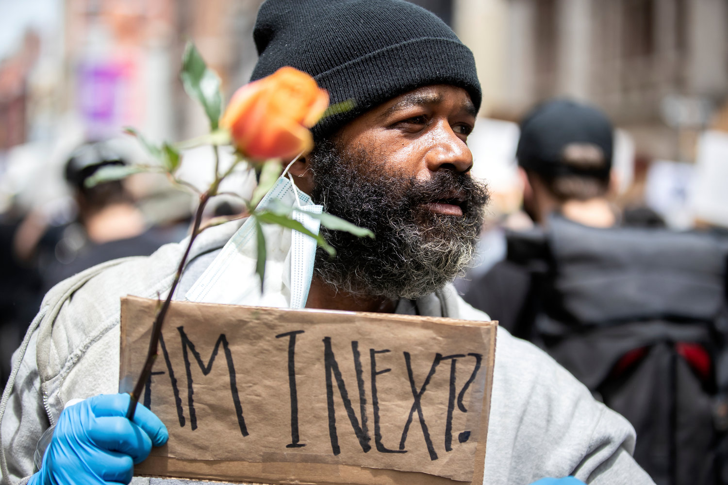](https://www.thejewishstar.com/uploads/original/20200610-140658-Glick%20Brutality%20protest%20black%20man.jpg)

**A man views a June 2 protest in New York City over the killing of George Floyd. Photo by Ira L. Black/Corbis via Getty**

Scattered among the thousands of cellphone videos depicting looting and destruction in the streets of America’s greatest cities are clips of a different sort. In these short videos, we see throngs of white people on their knees, bowing before black people and asking for forgiveness for their “white privilege” and the “structural racism” in the deplorable, irredeemable United States of America.

Earlier this week, presumptive Democratic presidential nominee former Vice President Joe Biden symbolically embraced these genuflecting denunciations of “white privilege” as the official position of the Democratic Party. Biden had himself photographed on bended knee with a group of African-Americans standing behind him during a visit to a church in Wilmington, Delaware.

These videos point to a socio-political phenomenon that sparked the riots throughout the country following George Floyd’s brutal death at the hands of a Minneapolis police officer. They also make clear the reason that the liberal media in the United States continues to back the protests despite the fact that from the outset they have involved wide-scale violence, destruction and looting.

Contrary to the narrative being pushed by the media and America’s elites, the riots are not a consequence of increased police brutality towards African-Americans. As Heather McDonald documented in the Wall Street Journal, over the past several years, police violence against black people has decreased significantly.

The violence we are seeing is a result of the steep radicalization of progressive white Americans. Biden gave voice to this radicalization last summer when, during a campaign appearance in Iowa he said, “We choose truth over facts.”

Last year, political scientist Zach Goldberg published an article in Tablet where he presented statistical data demonstrating the depth and breadth of the radicalization of white progressives over the past 10 years. Goldberg revealed that between 2010-2019, white progressives became the only demographic group in US history to prioritize the interests of other groups over its own interests.

White progressives prioritize the advancement of the interests of minorities and immigrants over their own and over those of American society as a whole. Moreover, as Goldberg showed, white progressive positions on race and immigration are more extreme than the positions black, Latino and Asian progressives hold on these issues.

Goldberg argues that the massive increase in internet usage by white progressives over the past decade is responsible for the radicalization. Online platforms have created an information bubble that has created a warped presentation of reality to those inside the bubble. In this warped reality, race relations are far worse than they are in reality. Hence, those who inhabit this bubble prefer “truth” as presented in the bubble to facts.

Goldberg is undoubtedly correct that the more time people spend inside their internet bubble the more removed they become from objective reality. But the internet isn’t the only source of the radicalization. The Obama presidency was also a factor.

• • •

When Barack Obama won the presidential race in 2008, many Americans believed his victory was proof the United States had overcome its racist past. Obama however, did not support this view. Throughout his tenure in office, Obama used the power of his position to resonate and legitimize positions on race that until then had been relegated to the leftist margins of American politics.

Obama cultivated the view that far from being a post-racial society, America is inherently racist and that American racism is structural — that is, it was baked in and impossible to overcome. In so doing, Obama gave credence to the false claim at the heart of the riots: that black Americans are under continuous, existential threat from the state as a whole and from law enforcement bodies first and foremost. Calls by Hollywood celebrities and Obama administration alumni to defund the police take this view to its logical endpoint.

A third cause of the radicalization of white progressives is the higher education system. The more radicalized campuses are, the more radicalized graduates become.

The radicalization of white progressive politics has been given its most dramatic expression in the refusal of progressive mayors and governors to act forthrightly to end the violence in their streets. Instead, we had the likes of New York Mayor Bill DeBlasio (whose daughter was arrested for participating in the mayhem) stand with those burning his city.

In a letter to police sergeants in the New York Police Department, Ed Mullen, president of the Sergeants Benevolent Association, gave expression to the distress of New York police officers. “I know we are losing our city,” Mullen wrote.

“We have no leadership, no direction, and no plan. I know that you are being held back and used as pawns,” he continued.

He then asked the sergeants to hold the line.

“Remember,” he added, “you work for a higher authority.”

For American Jews, the violent riots constitute a challenge on several levels. First, there is the challenge of squaring their political identity with their Jewish identity. As the 2014 Pew survey of American Jews showed, around half of American Jews identify as progressives. As progressives, many American Jews share the views of their non-Jewish progressive counterparts regarding the need to prioritize the interests of minority communities over their own interests.

But the Jews’ progressive desire to work on behalf of those demonstrating for African-Americans places their political identity on a collision course with their Jewish identity.

• • •

Black Lives Matter, the radical group leading the demonstrations, is an anti-Semitic organization. BLM was formed in 2014 as a merger of activists from the anti-Semitic Nation of Islam, the anti-Semitic Black Panthers and Dream Catchers. In 2016, BLM published a platform that has since been removed from its website. The platform accused Israel of committing “genocide” and referred to the Jewish state as an “apartheid” state.

The platform accused Israel and its supporters of pushing the United States into wars in the Middle East. The platform also officially joined BLM with the anti-Semitic BDS campaign to boycott, divest and sanction Israel. BDS campaign leader Omar Barghouti acknowledged this week that the goal of the BDS campaign is to destroy Israel. BDS campaigns on US campuses are characterized by bigotry and discrimination directed against Jewish students.

BLM’s platform’s publication was greeted with wall-to-wall condemnations by Jewish organizations from across the political spectrum. But today, Jewish progressive are hard-pressed to turn their backs on the group, despite its anti-Semitism. As white progressives, they believe they must fight America’s “structural racism” even at the cost of empowering social forces that reject their civil rights as Jews. As Jews, they feel that their rights should be protected. One progressive Jew tried to square the circle writing in the Los Angeles Jewish Journal, “Today Jews need to support Black Lives Matter; tomorrow we can talk about Israel.”

As white progressives radicalized over the past decade, radical Jewish progressives built a formidable Jewish organizational framework whose mission is to advance the progressive revolution. They have worked to recast Judaism itself as the apotheosis of progressive revolutionary ideals. under the banner of “tikkun olam.”

Last week Tablet published a 20,000-word essay titled “Bend the Jews,” about Bend the Arc, the flagship organization spawned by those efforts.

Bend the Arc first rose to the attention of the general public in 2018 in the wake of the massacre of worshippers at the Tree of Life Synagogue in Pittsburgh. The organization quickly put out a statement blaming President Donald Trump for the massacre. When Trump came to the congregations to pay his respects, Bend the Arc organized demonstrations against him.

Bend the Arc may not have members, but it has an annual budget of tens of millions of dollars. $28 million of its budget comes from three non-Jewish foundations that have no other foothold in Jewish organizational life. On the other hand, one of the funders, the Rockefeller Foundation, is well known for its generous support for radical anti-Israel and BDS groups.

To achieve its goal of reshaping the worldviews of American Jews, among other things, Bend the Arc trains Conservative, Reform and Reconstructionist rabbinical students. It also pays the salaries of associate rabbis in various communities. With many synagogues long steeped in financial crisis due to dwindling membership, Bend the Arc’s ability to pay rabbis makes its involvement with synagogue hiring an attractive option for many communities. This is doubly true for synagogues whose members are progressive.

• • •

As progressive politics paralyze Jews from acting against anti-Semites in their political camp, levels of anti-Semitic sentiment among white progressives are rising. As Goldberg reported, as white progressives became radicalized on issues related to minorities and immigration, they also turned against Israel. Today white progressives are hostile to Israel. And Goldberg argued that while they express support for Jews, “their sympathy toward and concern for Jews has become more conditional.”

What is it conditioned on? On Jews not being opposed by blacks or other minorities that are considered by white progressives to be less privileged than Jews are.

On the burning streets of America today, leftist Jew-hatred is on clear display. Although New York Mayor Bill DeBlasio has prevented New York police from taking firm action against looters and arsonists, he did instruct them to use all necessary force to prevent ultra-Orthodox Jewish children from going to school. Earlier this week, police in Brooklyn chased a group of Hassidic children and their mothers off a playground in Williamsburg.

Even worse, synagogues have been vandalized in New York and Los Angeles. According to Yeshiva World News, 75 percent of Jewish-owned stores in an Orthodox enclave of Beverly Hills were looted last weekend. Graffiti in Los Angeles made clear that the businesses and neighborhoods were targeted deliberately because they are Jewish.

Between BLM’s establishment in 2014 and the publication of its platform in 2016, anti-Israel activists went to great lengths to create an utterly false conceptual linkage between the Palestinians and African-Americans. Today, anti-Israel activists in the United States have stepped up their efforts to capitalize on the riots. Anti-Israel activists in Bethlehem painted a picture of George Floyd wearing a khaffiyeh and draped in a Palestinian flag on the separation barrier. Photos of the picture are being heavily promoted on social media.

Democrats believe the riots will wreck President Trump’s reelection hopes. Polls this week indicate that at least in the short term, the unrest is hurting Trump’s chances of being reelected. Then again, it’s possible the chaos in the streets will strengthen public support for President Trump, who voters may view as the last bulwark separating them from national destruction.

Whether Trump wins or loses in November, the radicalization of white progressives at the heart of the mayhem represents the greatest short and long-term threat to social cohesion in America. It also represents the greatest threat to the communal future of American Jewry, to relations between the American Jewish community and the rest of the Jewish world, and to US-Israel relations.

*Reprinted from last week’s edition of the Jewish Star (Five Towns, NY)*